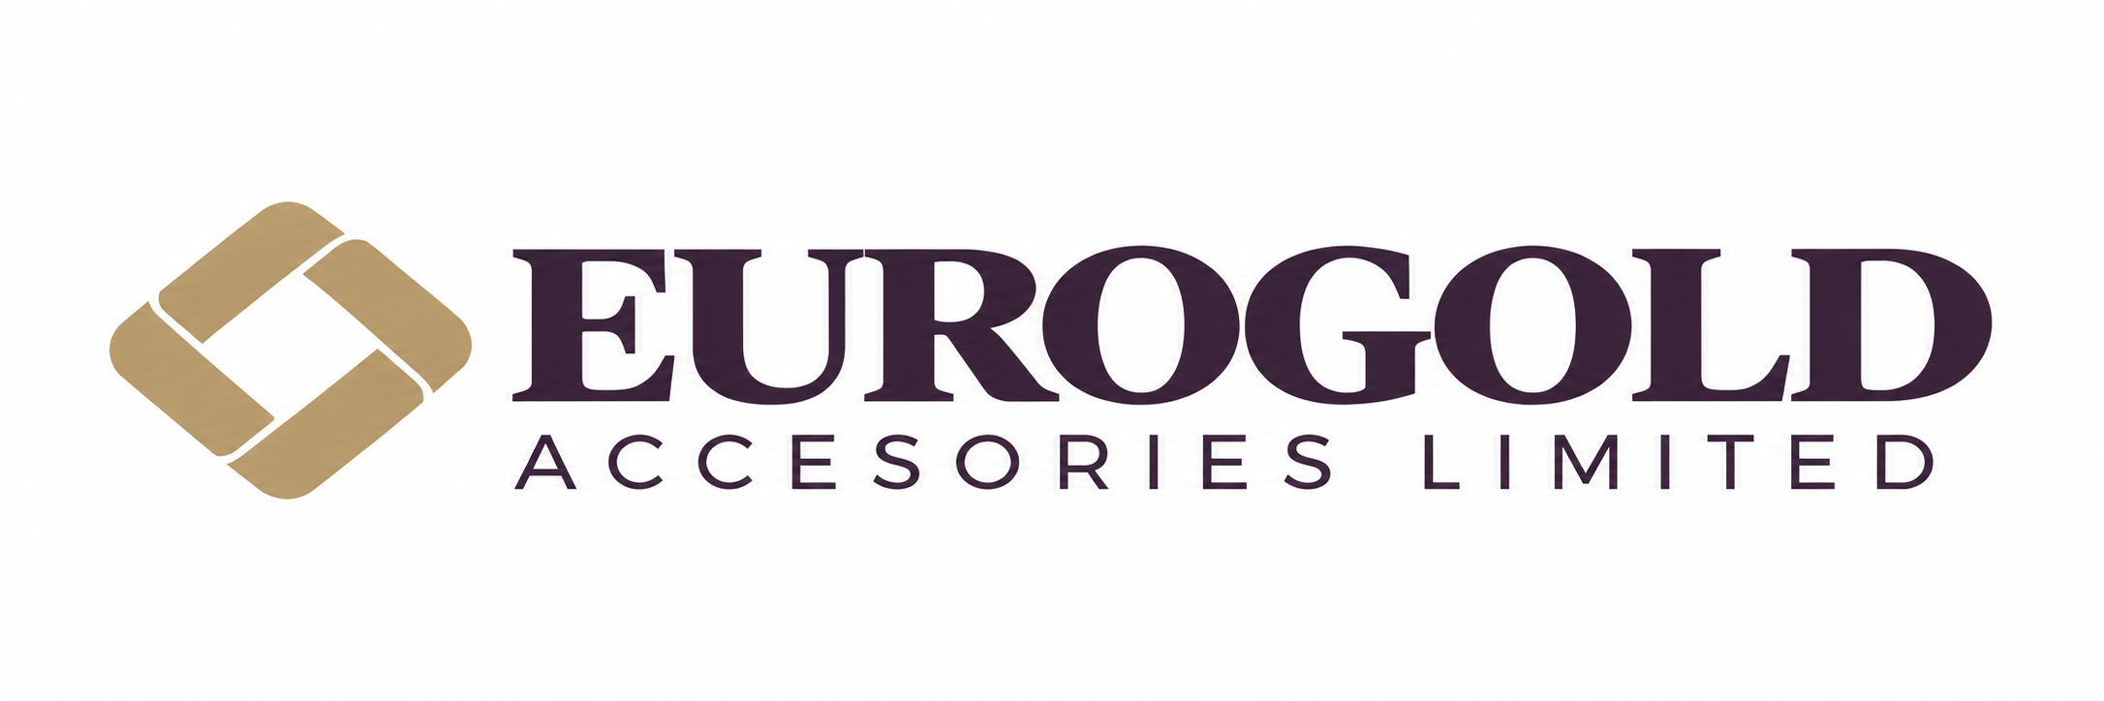

Company Introduction
Introduction for Japanese Trading Companies

Company overview
Eurogold Accesories Limited is a woven bag manufacturer based in Banyerchala, Bagerbazar, Gazipur, Bangladesh, with an annual manufacturing capacity of 1,300 metric tonnes. We are seeking cooperation with Japanese trading companies to source suitable polypropylene resin for our woven bag business.

Proposed cooperation
We are interested in virgin, prime-quality, Japanese-manufactured PP homopolymer for raffia and flat-yarn applications. TASNEE H1030 is our reference grade, with an MFR of 3 g/10 min at 230°C under a 2.16 kg load. We invite recommendations for a suitable equivalent, subject to technical evaluation and production-trial approval.
Please provide your recommended grade and technical datasheet, sample availability, confirmation of Japanese origin, minimum order quantity, lead time and payment terms. We request CIF Chattogram quotations for an initial container and a proposed 100 metric tonne order, subject to agreement.

Prominent customers
Our prominent customers include the following organizations.
  RFL |   BEXIMCO |   BRAC
  Renata PLC |   Partex Group |   Abul Khair Group

Contact
Abdus Salam | Executive Director
Telephone: +8801313019381 | Email: Abdus.salam.eurogold@gmail.com
Banyerchala, Bagerbazar, Gazipur, Bangladesh

